APP PROPOSAL: GYMMY

# Specification

The application I am proposing is a fitness app called Gymmy. The purpose of Gymmy is to keep track of one’s fitness journey in the gym. The user can create workout routines which will include various exercises from an exercise library, post their workouts, keep track of their fitness over a couple of weeks or annually .

Notifications will be sent daily at a specific time if the user hasn’t used the app at all for the day and this should make sure the user is held accountable with their fitness.

Gymmy solves the problem of not being able to track one’s fitness journey as well as creates a community of like-minded individuals that can help and support each other. This was inspired from the challenges my friends and I went through when we started our fitness journey. A user guide ill be part Gymmy which will help the user navigate through the app.

Functionality:

* User Profiles and Login Screen: Gymmy will require users to create a profile, including their name, age, gender, and fitness goals, to enable personalized fitness tracking and goal setting. The application will also have a login screen for registered users to access their accounts.
* User Interface: Gymmy will have a user-friendly interface with multiple screens for users to interact with. The interface will respond to the rotation of the device, making it easy to use on both mobile phones and tablets.
* Creating Routines: Users can create and delete workout routines from an exercise library consisting of a wide range of exercises. Gymmy will enable users to customize their routines based on their fitness goals, preferences, and fitness level.
* Database: Gymmy will store user account information securely in a database, ensuring the privacy and security of user data Post work out.
* Daily Notifications: To ensure accountability, Gymmy will send daily notifications at a specific time if the user hasn’t used the app at all for the day. This feature will encourage users to stay on track with their fitness journey.
* Calendar: Gymmy will have a calendar to track the user's fitness journey. Users can view their progress over time, set reminders for upcoming workouts, and track their progress towards their fitness goals.
* Workout Suggestionss: Gymmy will provide workout recommendations based on the user's fitness goals and preferences. The application will suggest workouts that are tailored to the user's fitness level and interests, making it easy to find the right workout routine.
* User Guide: Gymmy will have a user guide to help users navigate through the app. The guide will include instructions on how to use the app, how to create workout routines, how to track progress, and how to set and achieve fitness goals.
* Goal Notifications: When a user finishes a workout, Gymmy will send a notification to celebrate the user's accomplishment and encourage them to set new goals.
* Exercise Library: Gymmy's exercise library will be comprehensive, including a wide range of exercises that users can use to create their workout routines. The application will provide detailed instructions on how to perform each exercise.

# Mock screens

## Sign in screen

* User types in credentials so their data can be stores in a local database an online database will be used if I figure out I need it as development begins
* This is where the user creates their account

Login screen

* The login in screen will be what the user sees if they already have an account with Gymmy

* Users can see other users.
* The main part of this is where the user tracks their consistency with the gym. This will be represented by charts.
* Their consistency will be shown in days or months. however, they want it
* Notifications will tell them to go workout if they haven’t gone at all.

Creating Routine

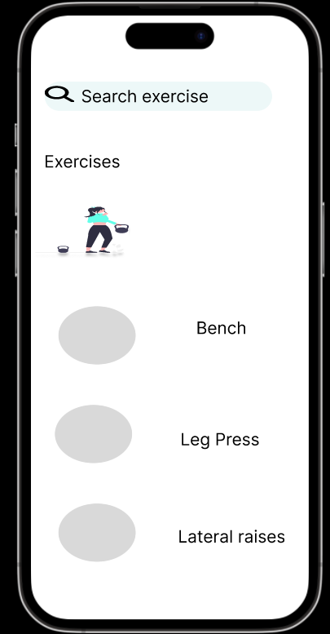

* The user creates their routine here, a routine is a group of exercises which the user follows regularly.
* By clicking add routine, the user is taken to a screen where they add various exercises to their routine.
* They can name the routine what ever they like and they can make as many routines as they wish.
* The exercise library will probably be stored in a database containing a list of various exercises which the user can chose from
* They then save their routine.
* I will also enable them to delete their routine if they want
* By clicking suggestions, they are taken to the recommendations page

Recommendation

Feed

* The feed screen is represented with the news icon
* Here the user can see other users other general users
* The user can post their workout for the day
* The user can react to another users workout by liking it

Settings

* The settings page is accessed from the user profile
* The user can go into their profile and make changes such as change username
* Th notifications bar is their which allows them to turn off any notifications
* There is also a users guide which contains how to use the app